|  |
| --- |
|  |
| 新概念 3 册 |
| Lesson43 |

Lesson 43 Fully insured

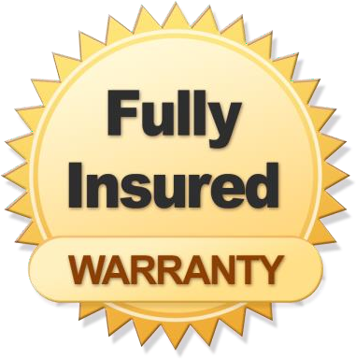

**insure [ɪn'ʃʊə(r)]**

**v. 投保，为……上保险**

insure … against …

I have insured my house against fire / burglary. I have insured myself against illness.

insure … for …

They’ve insured the painting for a million pounds. insure (US) / ensure (UK)

= make sure / certain

insure / ensure passenger safety

One more goal will ensure / ensure victory.

The role of the police is to insure / ensure (that) the law is obeyed. assure sb. of sth.

assure sb. (that) …

The dealer assured me of its quality.

I assure you (that) I’ll be there on time.

recover [rɪ'kʌvə(r)]

**v. 重新获得，找回，赚回，补偿；康复，恢复正常** Four paintings stolen from the gallery have been recovered. We recovered lost time by setting out early.

But the claim made by a local authority to recover the cost of salvaging a sunken pie dish must surely be unique.

recover sth. from sth.

Two bodies were recovered from the wreckage.

He was entitled to recover damages from the defendants. After a few days of fever, she began to recover.

recover from …

He's in hospital, recovering from a heart attack. Trade soon recovered from the effects of the war. recover restore regain

admittedly [əd'mɪtɪdli] adv. 诚然，的确，确实

admittedly adv. used, especially at the beginning of a sentence, when you are accepting that sth is true 诚然，的确，确实

Admittedly, he didn't know that at the time.

Admittedly it was an unusual pie dish, for it was 18 feet long and six feet wide. Admittedly, ..., but ...

Granted, …, but …

It is true that ..., but ...

Admittedly, it was difficult, but it wasn't impossible.

Granted, he doesn't look too bad for his age, but I don't fancy him.

It was true that he had just bought a lamb, he explained, but his lamb was black. It is true that / Admittedly, / Granted, ...,

but that is not to say that ... but it does not follow that ...

but it does not necessarily mean that ... but there is no guarantee that …

造句：确实很多大学生选择继续读研究生 (pursue their graduate studies)，但这并不意味着他们都想做学者。

Admittedly, many college students choose to pursue their graduate studies, but it does not necessarily mean that they want to be scholars.

annual ['ænjuəl]

**adj. 每年的，年度的**

annual income / meeting / ring annually adv.

The jazz festival is held annually in July. yearly adj. & adv.

yearly income / interest / budget The magazine is issued twice yearly. daily adj. & adv.

daily (=everyday) life

The zoo is open daily (=every day). weekly adj. & adv.

a weekly magazine

The group meets weekly (=every week). monthly adj. & adv.

a monthly salary of $850

They meet monthly (=every month) to discuss progress. biannual

biennial triennial

centennial millennial perennial

perennial happiness / youth

decade century millennium

teenager ['ti:neɪdʒə(r)]

**n. 13~19 岁的青少年**

teenager teen

a magazine aimed at teenagers / teens in one’s teens

She was in her teens when she met him. teenage

a teenage boy my teenage daughter youth

a gang of youths youngster

You youngsters have got your whole life ahead of you. minor

It is illegal to sell alcohol to a minor. adolescent

An adolescent between the ages of 13 and 19 is called a teenager. an adolescent boy

juvenile

Most of the suspects were juveniles under the age of 17. juvenile delinquent

juvenile delinquency

haul [hɔ:l]

**v. （用绳子）用力拖拉**

Rescue workers attached the men to ropes before hauling them to safety. drag

He dragged the heavy chest across the floor.

The police dragged the soccer hooligan off the pitch. tow

My car broke down and had to be towed to a garage. trail

She walked slowly along the path, her skirt trailing in the mud. tug

We tugged it so hard that the rope broke. pull / draw

agonizing ['ægənaɪzɪŋ]

**adj. 令人痛苦的， 令人伤脑筋的**

an agonizing injury

an agonizing choice / decision / dilemma agonized

an agonized expression / scream agonize about / over …

For days I agonized about whether to accept his advice. agony He groaned in agony.

vertically ['vɜ:tɪklɪ] adv. 垂直地

the vertically challenged the horizontally challenged diagonally

The path goes diagonally across the field. vertical / perpendicular

horizontal diagonal curved

circuitous / tortuous

The road is tortuous, but the prospects are bright. insurance

~ company ~ agent / broker

~ policy ~ premium medical care ~ endowment ~ unemployment ~ housing fund insurance

social ~ personal ~

commercial ~ life ~

accident ~ travel ~

fire ~ car ~

normally adv. 1. usually 通常

The journey normally takes about two hours. normally adv. 2. in a normal way 正常地Her heart is beating normally.

possessions / property property / real estate belongings / things

practice n. 习俗，惯例，习惯性的做法

On the other hand, your stomach would turn at the idea of frying potatoes in animal fat—the normally accepted practice in many northern countries.

If, *however*, you were holding an open air garden party or a fete *it* would be equally possible *to insure yourself in the event of bad weather*.

open-air = outdoor adj.

an ~ concert / swimming pool

in the open air = outdoors = out of doors adv. The wedding was held ~.

indoor adj. indoors adv.

fete n. BrE an outdoor event where there are competitions and things to eat and drink, usually organized to get money 游园会, 义卖会

in the event of … in case of …

The party will be held indoors in the event of / in case of rain. in any event = in any case = come what may

~ I shall go before Tuesday.

*Needless to say*, the bigger the risk an insurance company takes, the higher the premium you will have to pay.

needless to say

Needless to say, the man's name was Hans Bussman and he really was Franz's long-lost brother. The more he gets, the more he wants.

The harder you work, the greater progress you will make.

The more socialism spreads, the stronger *become* the forces of peace. The younger the child, the more the child’s need of sleep.

The younger the child *is*, the more *is / will be* the child’s need of sleep. The higher the standard of living, the greater the amount of paper used.

The higher the standard of living *is*, the greater *is / will be* the amount of paper used.

Needless to say, the bigger the risk an insurance company takes, the higher the premium you will have to pay.

Needless to say, the bigger the risk an insurance company takes *is,* the higher *will be* the premium you will have to pay.

It is not uncommon *to hear that a shipping company has made a claim for the cost of salvaging a sunken ship*.

it is not uncommon (for sb.) to do

It is not uncommon for students to have bank loans.

It is not uncommon for Chinese to be given names of popular slogans. claim n. 索赔要求

Fortunately for them, the Bank of England has a team called Mutilated Ladies which deals with claims from people who fed their money to a machine or to their dog.

make / file a claim for … drop / waive a claim for … allow / uphold a claim for … dismiss / reject a claim for …

But the claim made by a local authority *to recover the cost of salvaging a sunken pie dish* must surely be unique.

Fearing the authorities, Eric remained in hiding after the war as well.

It is all too easy to blame the railway authorities when something does go wrong.

It had been purchased by a local authority so that an enormous pie could be baked for an annual

fair.

**so (that) 作连词时一般来说有两种用法**：1. 引导结果状语从句，译为“所以”，从句谓语动词中一般没有情态动词。

2. 引导目的状语从句，译为“以便”= in order that …，从句谓语动词中多出现情态动词 can, could, may, might, should, would 等。

We paid him immediately, so (that) he left contented.

We paid him immediately, so (that) he would leave contented.

The pie committee decided that the best way to transport the dish would be by canal, so they insured it for the trip.

In the new country he became absorbed in making a new life for the two of us, so that he gradually ceased to grieve.

It had been purchased by a local authority so that an enormous pie could be baked for an annual fair.

This time they fixed heavy metal clamps to both sides of the dish so that they could fasten the chains.

bake v. to cook food in an oven without extra fat or liquid 焙烤

During a radio programme, a company of biscuit manufacturers once asked listeners to bake biscuits and send them to their factory.

fair n. a large public event where goods are bought and sold, usually from tables which have been specially arranged for the event, and where there is often entertainment 大型集市，庙会**decide 不一定译为“决定”，而常常译为“（在考虑之后）确定，断定，认为”，尤其是其后加 that 引导的宾语从句时。**

From then on, Harry decided that this little game he had invented might prove to be expensive. I decided that I must have taken a wrong turning somewhere.

Her first impulse was to go round all the rooms looking for the thieves, but then she decided that at her age it might be more prudent to have someone with her, so she went to fetch the porter from his basement.

shortly before / after …

The accident happened shortly before midday. I saw him shortly before he died.

Police arrived at the scene shortly after midnight.

Shortly after it was launched, the pie committee went to a local inn to celebrate. Shortly afterwards

Shortly afterwards, four more policemen arrived and remonstrated with the workmen. long before / after …

He was known to us all as Dickie and his eccentricity had become legendary long before he died. She was sentimentally attached to this house, for even though it was far too big for her needs, she persisted in living there long after her husband's death.

launch v. to put a boat or ship into the water 使船下水

The lifeboat was launched immediately to rescue the four men.

inn n. a small hotel or pub, especially an old one in the countryside（乡下的）酒馆，客栈be more than … can / could...

When my old friend Brian urged me to accept a cigarette, it was more than I could bear.

The pain is more than I can bear. The story is more than I can believe.

The beauty of the West Lake is more than words can describe.

The weather turned out to be very good, which was more than we could expect.

The pie committee telephoned a local garage owner and the owner arrived in a recovery truck to salvage the pie dish.

a recovery vehicle / truck

one for taking broken-down cars, etc. to a garage 维修拖车（把毁坏的汽车等拉回修理厂的车） Shivering in their wet clothes, the teenagers looked on *while three men dived repeatedly into the water to locate the dish*.

shiver / tremble

She shivered at the thought of going into the dark house alone. We were trembling with excitement.

The bridge trembled as the train sped across it.

Shivering in their wet clothes, the teenagers looked on while three men dived repeatedly into the water to locate the dish.

Suddenly, there was a slight trembling sound from below, and the captain went down to see what had happened.

By this time her legs were beginning to tremble, so she sat down and accepted a cup of very strong tea, while he telephoned the police.

look on

The gaoler looked on eagerly, anxious to see if his fellow-actor had at last learnt his lines. onlooker

We look on her as a daughter. locate

They located the right chimney by tapping at the walls and listening for the man's cries. have difficulty (in) doing sth.

have trouble (in) doing sth. have a hard time doing sth.

She had a hard time writing the dear John letter. have a good time doing sth.

The sides of the dish were so smooth that it was almost impossible *to attach hawsers and chains to the rim without damaging it*.

hawser n.（船上的）粗缆绳

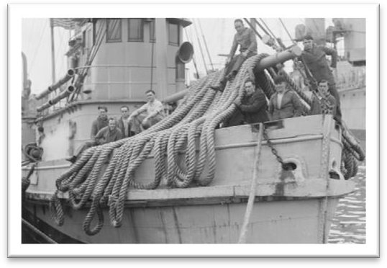

fix sth. to / on sth.

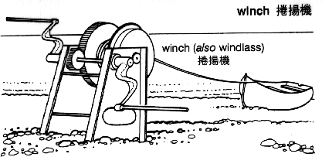The shelves should be fixed to the wall with screws. winch n. 绞车，卷扬机

put / bring sth. into operation

to make sth start working 开动，实施，使生效

It's time to put our plan into operation.

New legislation will be brought into operation in January.

gently adv. carefully, without a lot of force or sudden change in movement 小心翼翼地

Frank gently lifted the crockery out of the box and suddenly noticed a miniature painting at the bottom of the packing case.

moment n. 1. a particular point in time

Just at that moment there was a knock on the door. moment n. 2. a very short period of time

I'll come back to that point in a moment.

It was quiet for a moment, then Rae spoke.

'I don't understand,' said Lucy after a moment. perch be perched on …

The path led to a tiny village (which was) perched on the steep sides of a mountain. precarious

a precarious future

He is in precarious health. precariously

They lived precariously on the income from a few small investments. overbalance v. 失去平衡

be / feel obliged to do sth.

However, as the evidence began to accumulate, experts from the Zoo felt obliged to investigate, …

He had been obliged to join the army during the Second World War.

clamp n. device for holding things tightly together, usu by means of a screw 夹具，夹钳

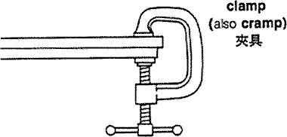 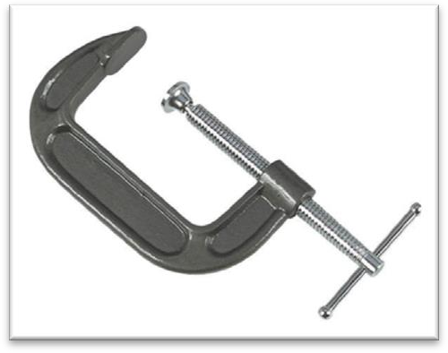

rest (sth.) on / against sth.

She stood three feet high and her hands rested on her hips. start (sth.⇔) up

if an engine, car etc. starts up, or you start it up, it begins working The driver got back into the car and started up.

Rory started up the engine and got the vehicle moving.

Water streamed in torrents over its sides *with such force that it set up a huge wave in the canal*. torrent n. 洪流

in torrents

The rain came down in torrents.

current stream trickle

The trickle became a stream; the stream has now become a torrent. such … that …

He wanted to buy a £300 watch for his wife, but he was in such *a bedraggled condition* that an assistant refused to serve him.

set up 造成，导致

It is as if a single unimportant event set up a chain of reactions.

There was a danger that the wave would rebound off the other side of the bank and send the dish *plunging into the water again*.

there is / was a danger that …

This greatly reduced the speed of the ship, for there was a danger that if she travelled too quickly, this rudder would be torn away as well.

there is always hope that … there is no denying that ...

there is no doubt / question that ... there is every likelihood that ... there is little likelihood that ... there is no shortage of ...

there is an element of truth in ... there is a good deal of truth in ... rebound from / off … 从……反弹回来

The ball rebounded from / off the goalpost and Owen headed it in. send … doing

A fire in the casino sent people fleeing for safety.

A careless step sent rocks tumbling down on the climbers below.

By working at tremendous speed, the men managed to get the dish on to dry land *before the wave returned*.

dry land n. land rather than water

陆地

After three weeks at sea we were glad to be back on dry land again. She stands on dry land and is visited by thousands of people each year.